Course Name: | Web Programming Laboratory (216U01L405) | Semester: | IV
Date of Performance: | 05 / 02 / 2026 | DIV/ Batch No: | B - 1
Student Name: | Tarush Dhamne | Roll No: | 16010124073

Experiment No: 1
Title: Design web Portal using CSS3.

Aim of the Experiment: To apply CSS3 style sheets to an existing HTML5-based Web Portal in order to enhance layout, responsiveness, visual aesthetics, and user interaction using modern CSS3 features.

Objectives for the Experiment:
- Implement different CSS3 styling techniques
- Design responsive layouts using Flexbox and media queries
- Enhance user interaction using animations
- Maintain separation of content and presentation

COs to be achieved:
CO1: Use CSS to prepare the layout of web pages.

Books/ Journals/ Websites references:
- Students should write

Theory:
Students should write about CSS3 (citation needed for content taken (IEEE or APA7 style))

Problem statement: “Task 1: Apply Different Types of Style Sheets
CSS Topic: Inline, Internal, External Style Sheets
Create a simple homepage for the transport portal and:
- Use inline CSS to style one heading
- Use internal CSS (<style>) to style navigation menu
- Use external CSS file to style the whole page layout.
Task 2: Linking External CSS using <LINK> Tag
- CSS Topic: Linking style information in separate file
- Create an external file style.css and:
- Link it using <link> tag
- Style body background, fonts, and colors
- Apply consistent theme for the portal

Task 3: Setting up Style Information for Route Cards
- CSS Topic: Selectors, classes, IDs
- Design route information cards showing:
- Route number
- Stop sequence
- Timing
Use:
- Class selectors for cards
- ID selector for highlighted route
- Group selectors for text formatting
Task 4: Embedded CSS using <STYLE> Tag
- CSS Topic: Internal CSS
- Create a “Bus Stop Details” page and:
- Use <style> inside <head>
- Format tables for stop names and timings
- Apply border, padding, hover effects
Task 5: Flexbox Layout for Stop Sequence Display
- CSS Topic: Flexbox (Advanced CSS3)
- Display stop sequence horizontally like:
- Stop 1 → Stop 2 → Stop 3 → Stop 4
Use:
- display: flex
- justify-content
- align-items
- Responsive alignment

Task 6: CSS Media Queries for Responsive Design
CSS Topic: Media Queries
Make the portal responsive:
- Desktop: Routes in grid format
- Mobile: Routes in single column
- Adjust font sizes and menu
Task 7: CSS Animation for Delay Notification
CSS Topic: CSS Animation
Create a delay alert box:
- Blinking red notification for delayed bus/train
Use @keyframes
Smooth animation effects

Task 8: Styling Navigation Bar using Multiple CSS Approaches
CSS Topic: Using multiple approaches together
Create a navbar where:
- Inline style for logo
- Internal CSS for menu
- External CSS for hover effects and layout

Task 9: Use Chrome DevTools to Inspect and Modify CSS
Tool Topic: Elements Tab, Console Tab
Open the portal in Chrome and:
- Inspect CSS applied to route cards
- Modify colors, margin, padding live
- Observe changes without editing code

Task 10: Network & Sources Tab for CSS Debugging
Tool Topic: Network, Sources Tab
- Check if style.css is loading properly
- Observe file loading in Network tab
- Edit CSS live in Sources tab

CODE:
Google drive link:

https://drive.google.com/drive/folders/1CBDV_zjXBCMfkQ6k9udbcc5mYjDKUH6s?usp=sharing

Output / Screenshot:
1. Homepage – Railway Transport Information System

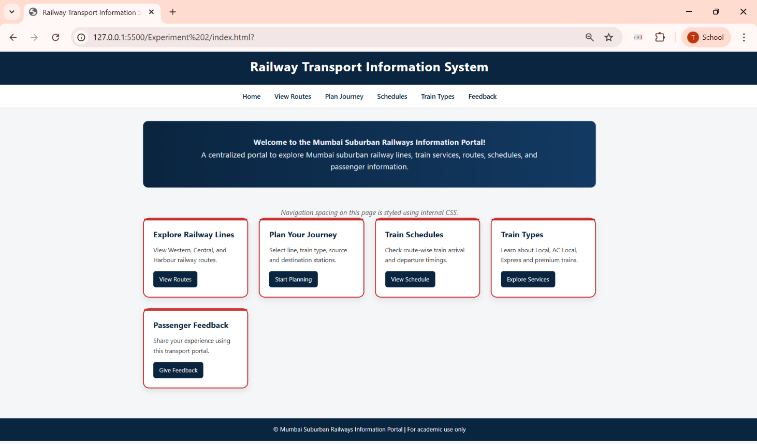

- Explore Railway Lines Page

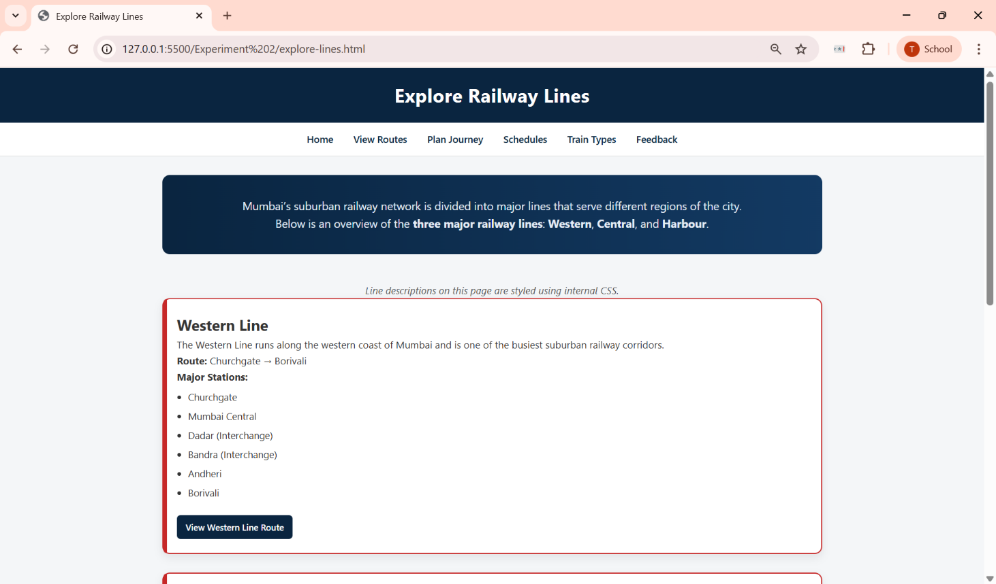

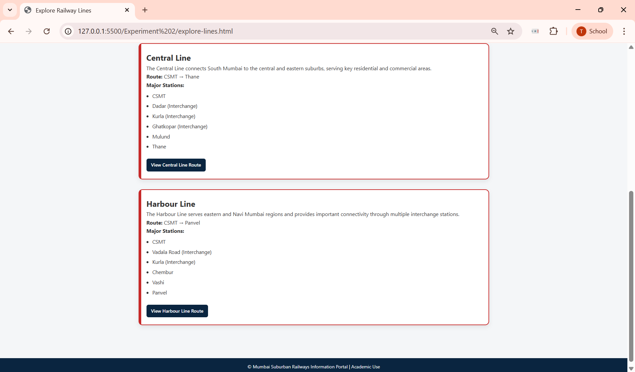

- Plan Your Journey Page – Line Selection and Station Selection Form

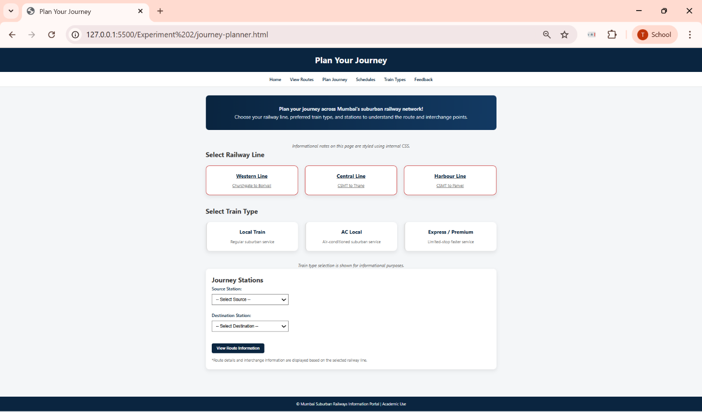

- Western Line Route Information Page

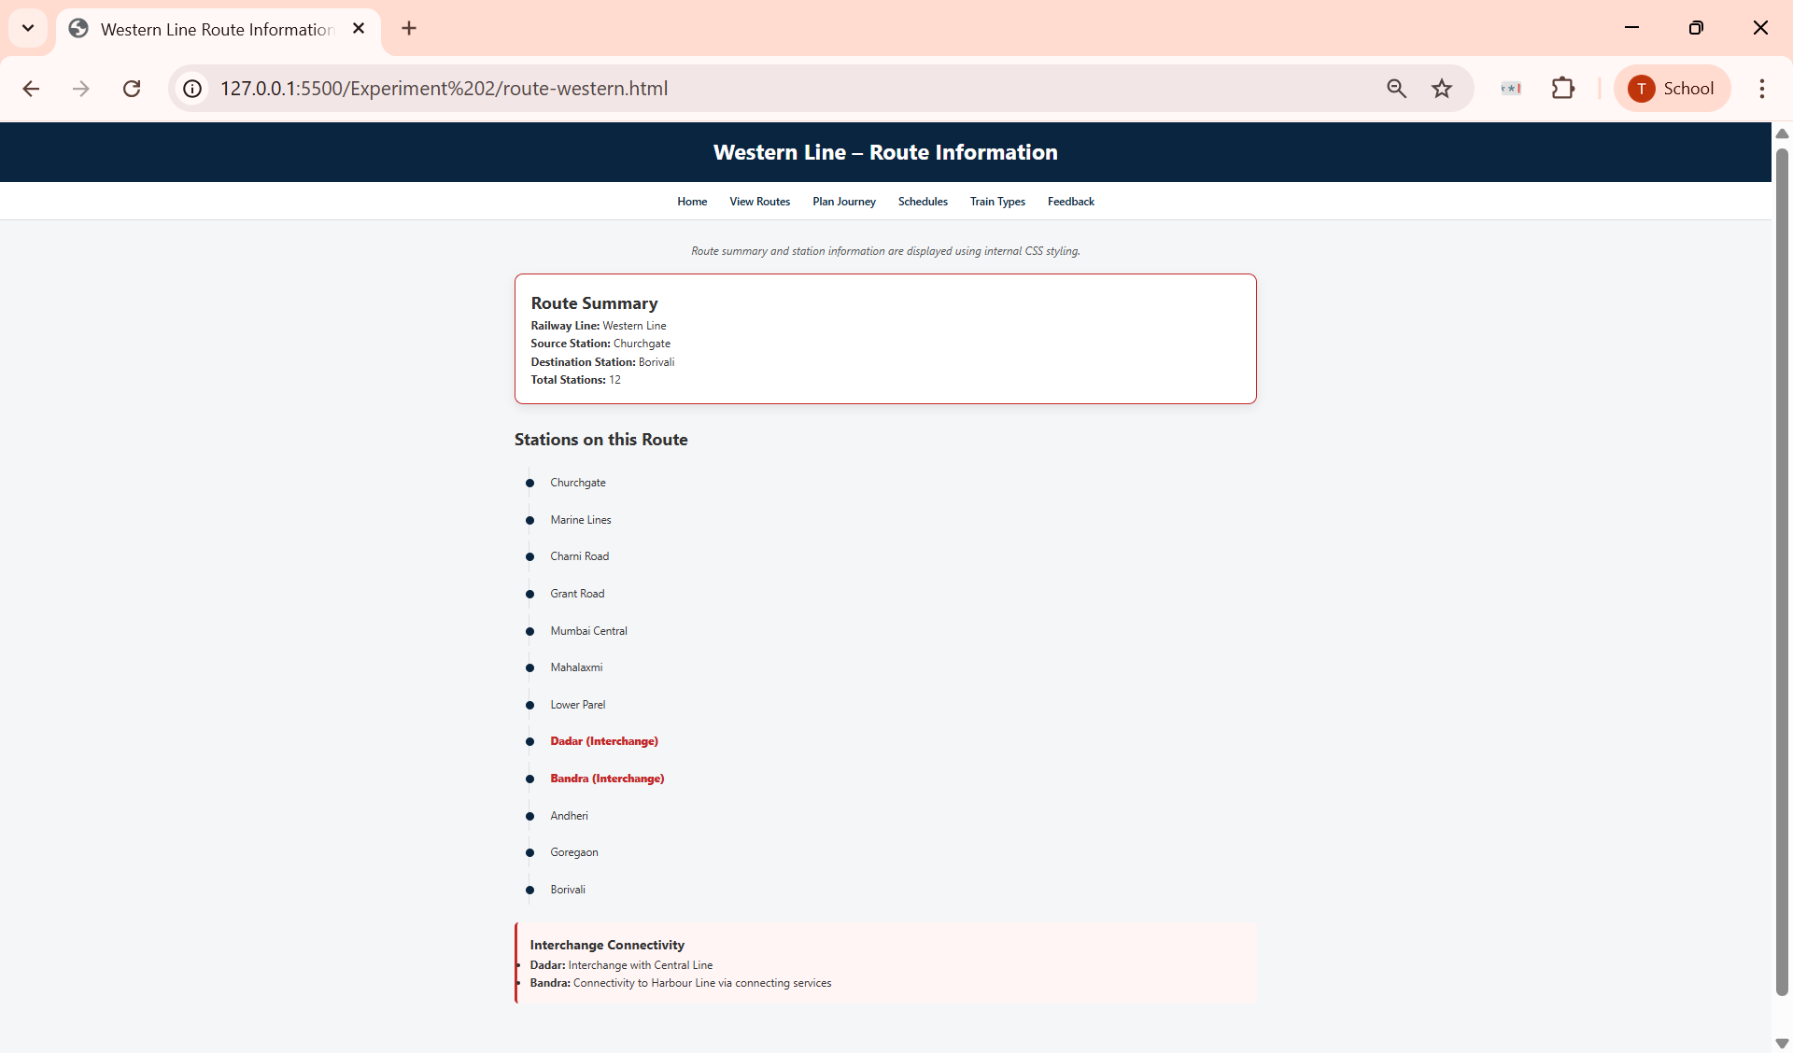

- Central Line Route Information Page

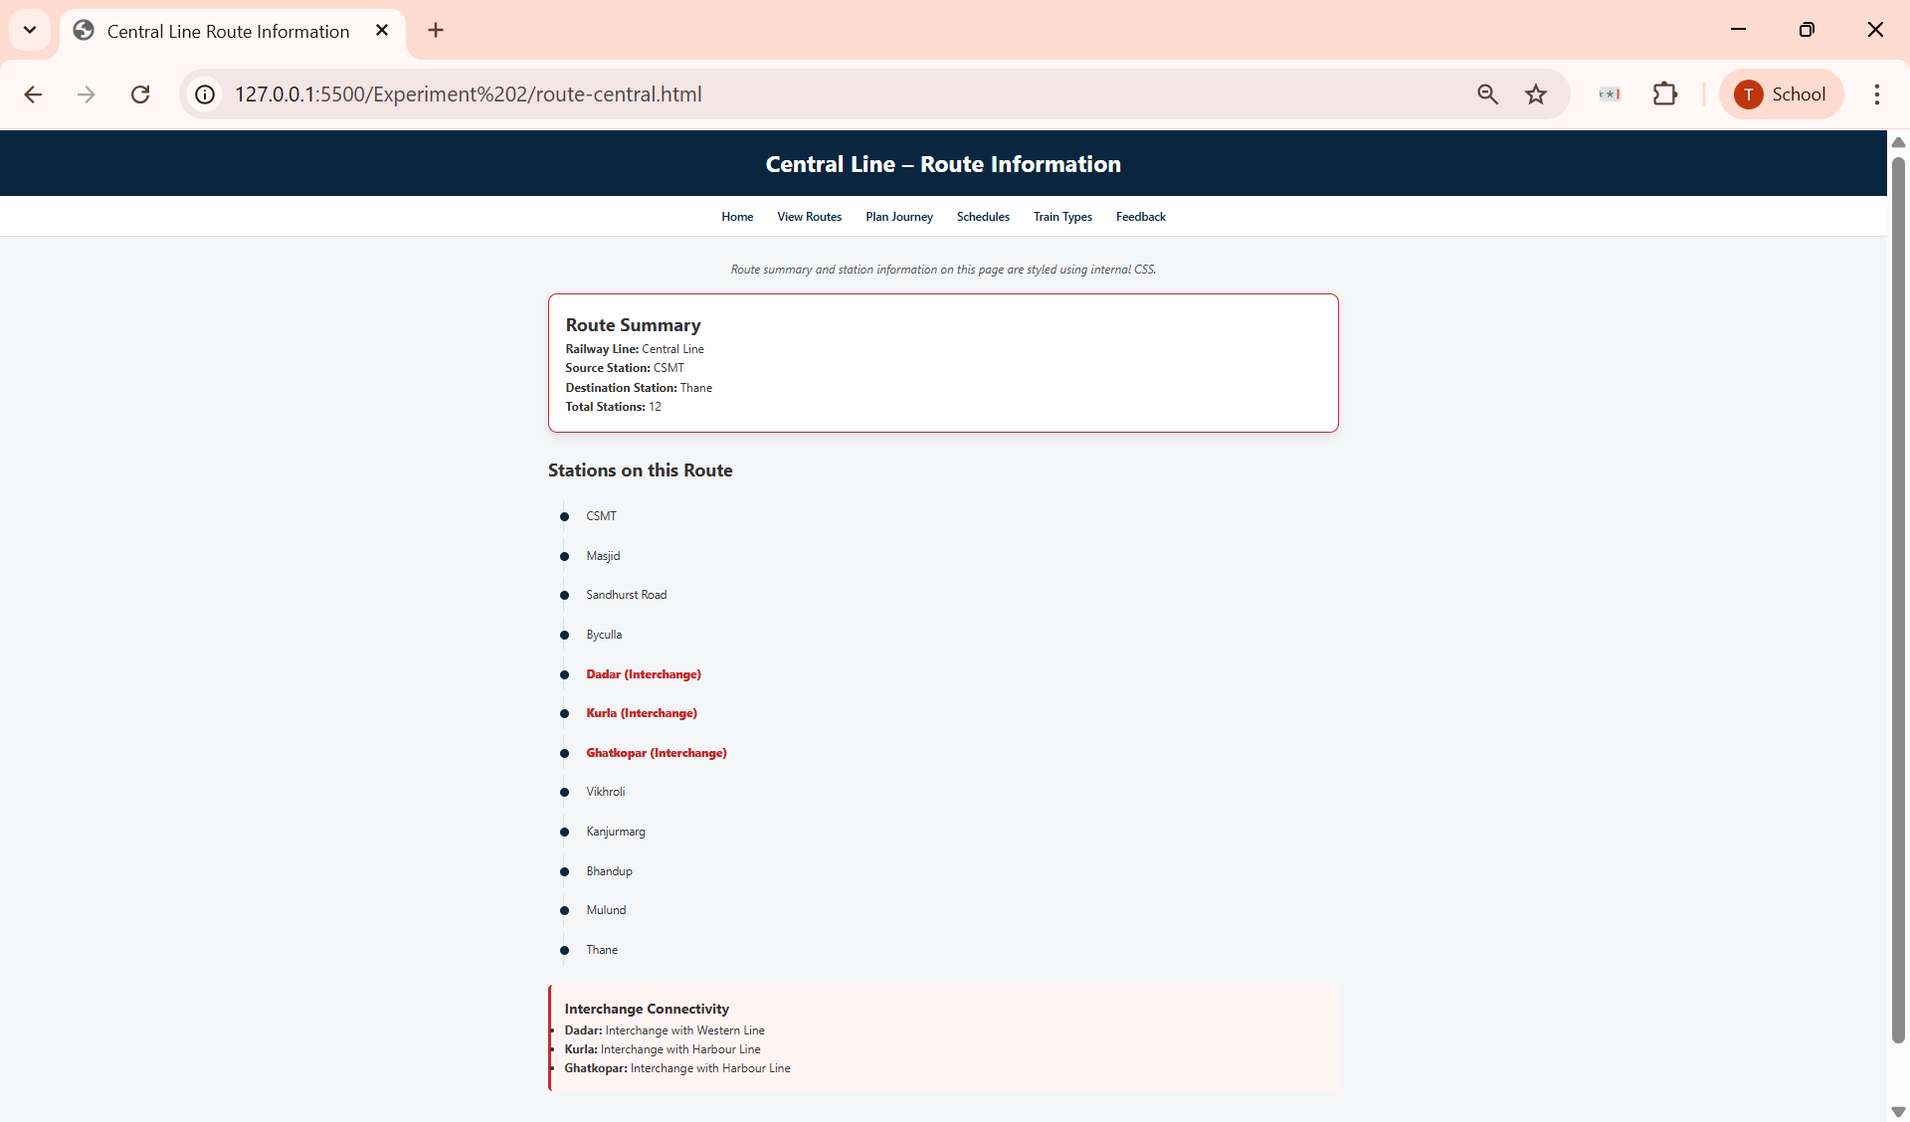

- Harbour Line Route Information Page

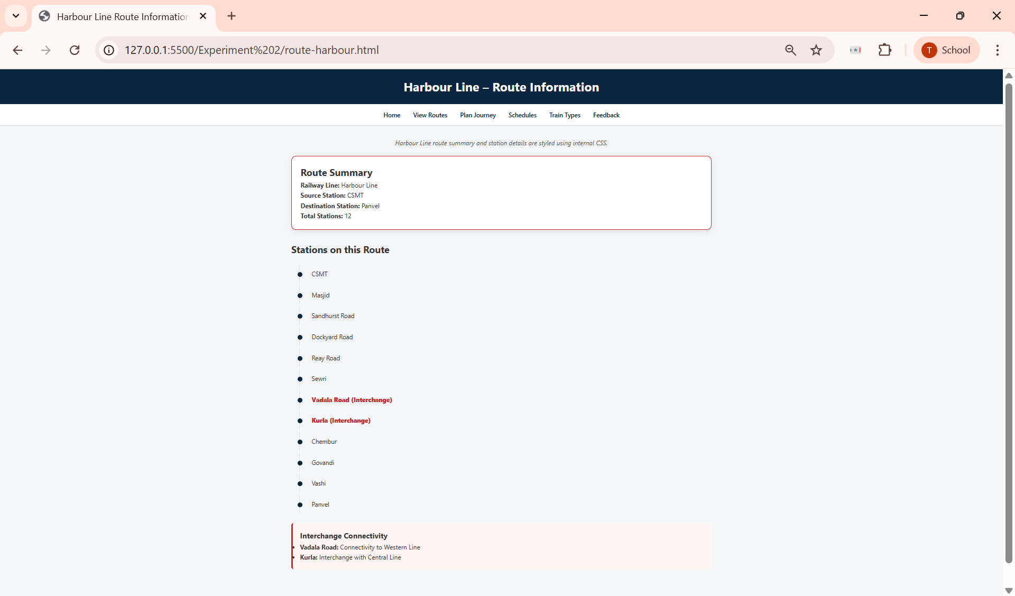

- Train Schedules Page

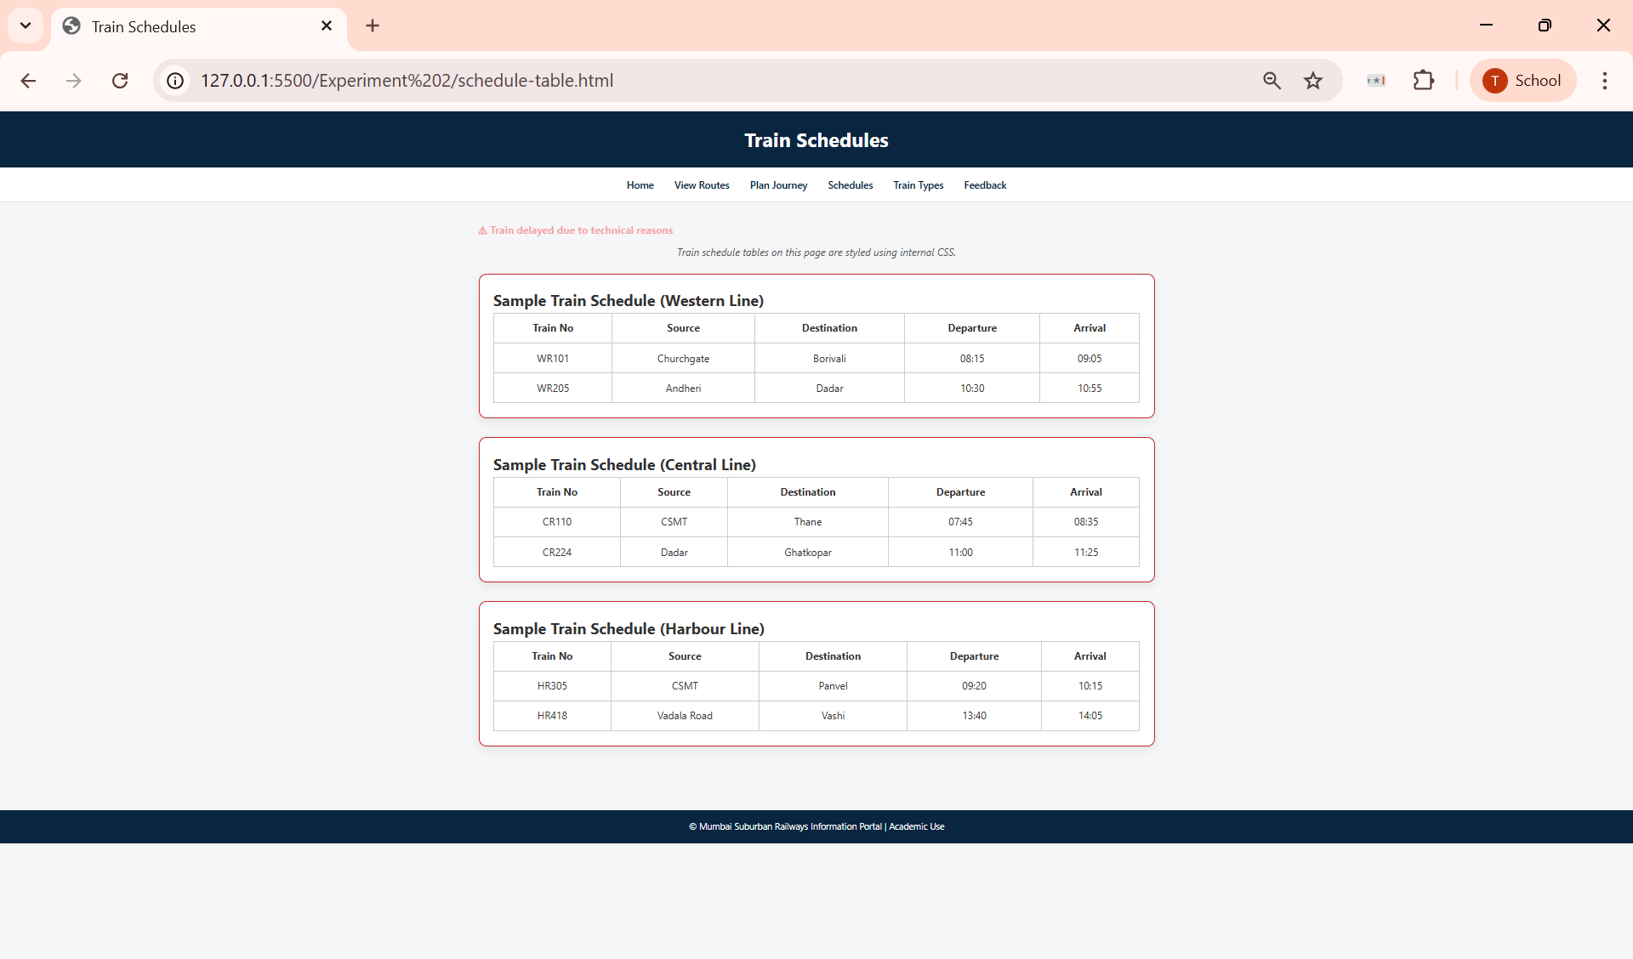

- Train Types Page

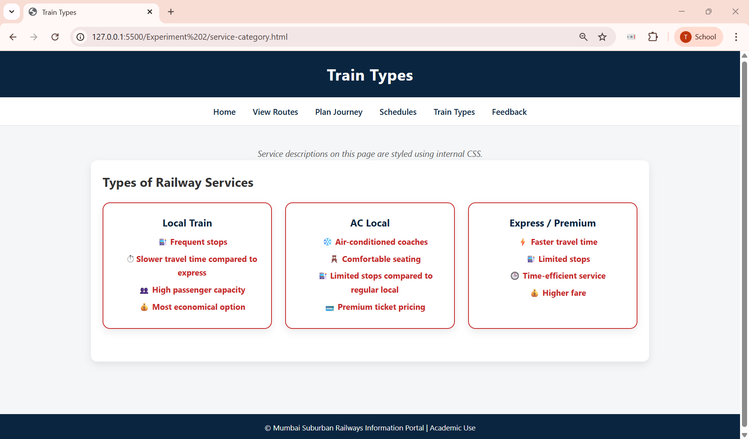

- Passenger Feedback Form

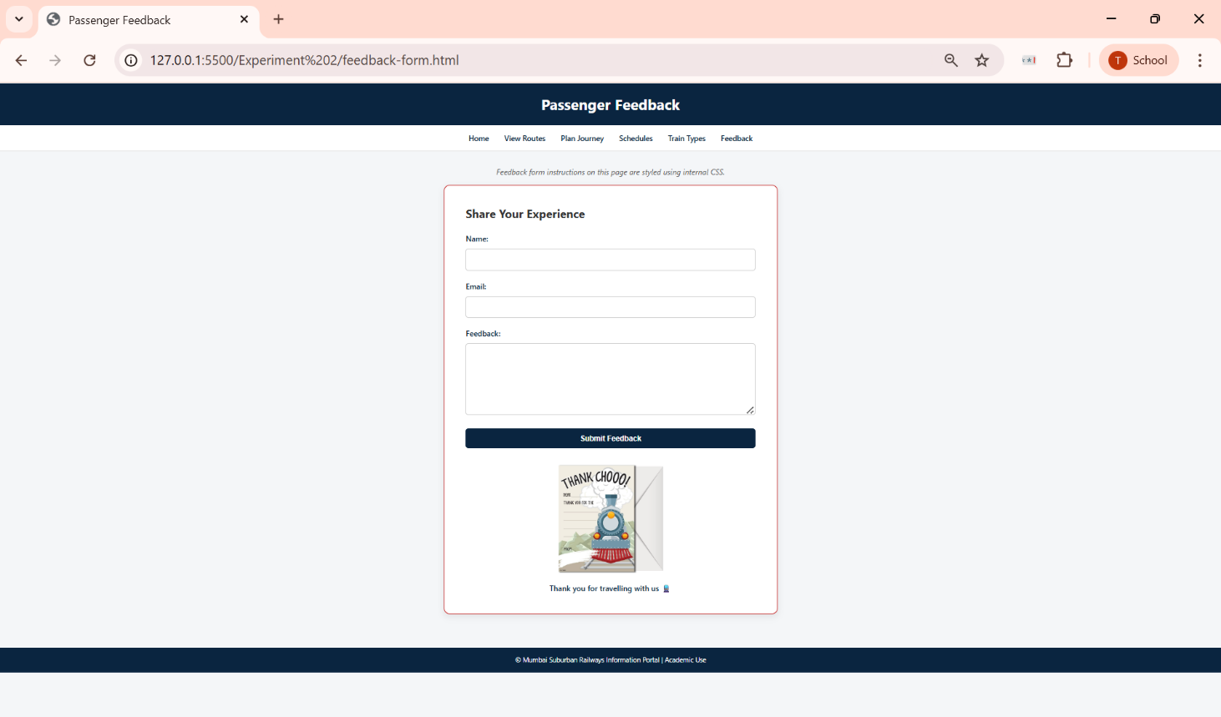

Post Lab Subjective/Objective type Questions:
- Write CSS code to create a responsive layout using Flexbox.
Answer:
Flexbox allows elements to align and distribute space dynamically, making layouts responsive across different screen sizes.

CSS Code:
.container {
display: flex;
gap: 20px;
justify-content: space-between;
flex-wrap: wrap;
}

.box {
flex: 1;
min-width: 250px;
background-color: #ffffff;
padding: 20px;
border-radius: 8px;
}

- Write a media query for screens smaller than 768px.
Answer:
Media queries allow CSS to apply styles conditionally based on screen size.

CSS Code:
@media (max-width: 768px) {
.container {
flex-direction: column;
}

.main-nav a {
display: block;
margin: 10px 0;
text-align: center;
}
}

- Justify the use of CSS animations in user interfaces.
Answer:
CSS animations improve user experience by making interfaces more interactive and visually engaging. They help guide user attention, provide visual feedback, and enhance usability without relying on JavaScript.

Justification Points:
- Highlight important actions (e.g., alerts, buttons).
- Provide feedback for user interactions.
- Improve user engagement.
- Lightweight and performance-efficient.
- Enhance modern UI appearance.

- Design a CSS animation for a call-to-action button.
Answer:
A call-to-action button can be animated to draw user attention using CSS keyframes.

CSS Code:
.cta-button {
background-color: #C62828;
color: white;
padding: 12px 24px;
border-radius: 6px;
border: none;
font-size: 16px;
cursor: pointer;
animation: pulse 1.5s infinite;
}

@keyframes pulse {
0% {
transform: scale(1);
}
50% {
transform: scale(1.05);
}
100% {
transform: scale(1);
}
}

- Create a responsive navigation menu using Flexbox and media queries.
Answer:
A responsive navigation menu adapts to different screen sizes using Flexbox and media queries.

CSS Code:
.navbar {
display: flex;
justify-content: center;
background-color: #0A2540;
padding: 12px;
}

.navbar a {
color: white;
margin: 0 15px;
text-decoration: none;
font-weight: 600;
}

@media (max-width: 768px) {
.navbar {
flex-direction: column;
}

.navbar a {
margin: 10px 0;
text-align: center;
}
}

Conclusion and Discussion:
(students should write in your words)
(Also get feedback from fellow classmates (minimum 3) and faculty to add here)

Conclusion and Discussion
Conclusion
In this experiment, a responsive Railway Transport Information System web portal was successfully designed and developed using HTML and CSS. The objective of the experiment was to understand the practical application of different CSS techniques such as inline CSS, internal CSS, and external CSS, along with modern layout concepts like Flexbox, Grid, media queries, and animations.
The website provides structured information related to Mumbai’s suburban railway system, including railway lines, route details, train schedules, types of train services, journey planning, and passenger feedback. By implementing responsive design techniques, the website adapts well to different screen sizes, improving usability across devices. The use of CSS animations enhanced the user interface by drawing attention to important alerts and actions without affecting performance.
Overall, the experiment helped in strengthening concepts of frontend web development and demonstrated how CSS plays a crucial role in improving both functionality and user experience of a web application.

Discussion
During the development of the project, various design and implementation decisions were taken to ensure clarity, responsiveness, and ease of navigation. Flexbox and Grid were used to maintain proper alignment and spacing of elements, while media queries ensured that the layout remained usable on smaller screens. Consistent navigation across all pages improved the overall user experience.
Feedback was taken from fellow classmates and faculty members to evaluate the usability and presentation of the website:

- The layout was clean and easy to understand. The journey planner and route information pages were well-structured and intuitive.
- The consistent navigation bar across all pages made the website easy to navigate. The train types section was visually appealing and informative.
- The route timeline and interchange information were clearly highlighted, making it easy to understand travel routes.

Based on the feedback received, the website effectively meets the requirements of the experiment and demonstrates practical understanding of responsive web design concepts.

